**Phone Book Application**

**BACHELOR OF TECHNOLOGY**

**in**

**COMPUTER SCIENCE AND ENGINEERING**

By

**K V V Siva Ram Kumar**

**Registration number: 12220696**

Supervisor

**Ms. Sonia Malik**

**School of Computer Science and Engineering**

Lovely Professional University

Phagwara, Punjab (India)

**Abstract:**

The Phone Book application is a console-based program developed in Java designed to manage contacts efficiently. It offers functionalities to add, delete, update, search, and display contacts. The application leverages Java's standard libraries, including HashMap for data storage and ‘**Scanner**’ for user input, ensuring an interactive and user-friendly experience

**Introduction:**

Managing contacts is a fundamental requirement for personal and professional use. The Phone Book application addresses this need by providing a simple, intuitive interface to handle contact information. It enables users to perform essential operations on contacts and ensures data integrity through input validation mechanisms.

**Objective of the Project:**

The primary objective of this project is to develop a robust and user-friendly phone book application that allows users to:

1. Add new contacts with validation.
2. Delete existing contacts.
3. Update contact information.
4. Search for contacts by name.
5. Display all contacts in the phone book.

**Description of the Project:**

The Phone Book application uses a HashMap to store contacts, where the contact’s name is the key, and the phone number is the value. The program operates through a command-line interface, providing users with a menu of options to manage their contacts. Input validation is a crucial aspect of this application, ensuring that only numeric values are accepted as phone numbers.

**Implementation:**

The implementation of the Phone Book application involves several key components:

**1. Data Structure:**

* HashMap<String, String>: Used to store contacts with names as keys and phone numbers as values.
* The key is the contact’s name, and the value is the phone number.

**2. Phone Number Validation:**

• A private method isNumeric(String str) checks if a string is numeric.

• It tries to parse the string into a Long and returns ‘**true**’ if successful, otherwise ‘**false**’.

**3. User Interaction:**

• A **Scanner** object reads user input from the console.

• The program continuously prompts the user for commands and executes the

appropriate functionality based on the input.

**4. Core Functionalities:**

• **Add Contact:**

* Prompts the user to enter a contact name.
* Checks if the contact already exists.
* If the contact doesn't exist, it prompts the user to enter a valid phone number.
* The phone number is validated to ensure it contains only numeric characters.
* Adds the contact to the phone book if the phone number is valid.

• **Delete Contact:**

* Prompts the user to enter the contact’s name to be deleted.
* Deletes the contact if it exists.
* Displays an appropriate message if the contact is not found.

• **Update Contact:**

* Prompts the user to enter the contact’s name to be updated.
* If the contact exists, it prompts the user to enter a new valid phone number.
* Updates the contact's phone number if the new number is valid.
* Displays an appropriate message if the contact is not found.

• **Search Contact:**

* Prompts the user to enter the contact’s name to search for.
* Displays the contact's details if found.
* Displays an appropriate message if the contact is not found.

• **Display Contacts:**

* Displays all contacts stored in the phone book.

• **Exit:**

* Exits the program.

**ScreenShots:**

**Contact Book:**

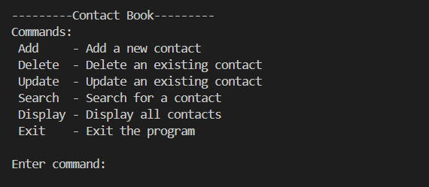

**Add Command:**

**Display Command:**

**Search Command:**

**Conclusion:**

The Phone Book application is a functional and user-friendly program that demonstrates the effective use of Java's data structures and standard libraries. Through careful input validation and a simple command-line interface, the application provides an efficient solution for managing contacts. This project not only serves a practical purpose but also showcases fundamental programming concepts and best practices in Java.